USE OF AGRICULTURE RESIDUES UTILIZATION TO OBTAIN BIOENERGY AND BIOFERTILIZER

TABLE OF CONTENTS
1.0 Introduction 3
1.1 Purpose 3
1.2 Background 3
1.3 Document overview 4
2.0 Materials and methods 5
2.1 Design and fabrication of converter 5
2.1.1 Specifications of Materials 5
2.2 Conversion of rice husks to biochar and Bio-fuel briquettes 7
2.2.1 Feedstock selection 7
2.2.2 Biochar Attributes 7
2.2.3 Carbonization process 7
3.0 Biofuel Production 9
3.1 Milling 9
3.2 Biofuel briquette 9
4.0 Biofertilizer Production 11
5.0 Conclusion 11
5.1 Strengths 11
5.2 Challenges 11
6.0 Recommendations of technical fabrication 12
7.0 Annexes 12

1.0 Introduction

1.1 Purpose
To develop small-scale, low-cost (US$20-100), portable biomass conversion unit that can be latched onto the back of tractors and even donkey carts, and that can deploy to rural farms to locally upgrade and process the low-value crop residues like rice husks and coconut shells into higher-value biofuel and biofertilizer. The technology will enable agricultural input-output companies to create a closed loop trash-to-cash value chain that enhances rural livelihoods. For example, the biofertilizer that the process can produce has already been tested in Kenya among 3,500 farmers to help reverse soil degradation and improve nutrient retention, thereby improving their yields by up to 27% and net income by 50%.
The project is implemented in collaboration with two partners: Takachar and Agricycle. Agricycle is a vertically integrated, for-profit agriculture input-output company. Takachar specializes in developing small-scale, decentralized technologies that can turn residues into higher-value bioproducts in rural communities. The technology will benefit Agricycle and the network of smallholder farmers, direct customers and suppliers of Agricycle who locally add value to the produce (for example by drying the mangos in a decentralized manner), and then helps them sell these value-added produce at a premium. In some regions of Tanzania, Agricycle’s farmers face long-term soil degradation and acidification stemming from improper use of acidulated chemical fertilizers. This has negatively affected the farmers’ yields.
Biomass resources include grain husks, nutshells, manure,crop residues, aquatic plants and algae. The conversion technologies for utilizing biomass can be separated into four basic categories: direct combustion processes, thermochemical processes, biochemical processes and agrochemical processes. Here we focus on thermochemical conversion processes that can be subdivided into gasification, pyrolysis, supercritical fluid extraction and direct liquefaction. Pyrolysis is the thermochemical process that converts biomass into liquid, charcoal and non-condensable gases, acetic acid, acetone and methanol by heating the biomass to about 476. 85 °C in the absence of air. The biomass conversion unit produces biofertilizer and bio-fuel. The bio-fertiliser holds promise to improve farmers’ yields, which will also increase the company’s productivity. Furthermore, farmers can use the biofuel to heat their homes and potentially sell to Agricycle for their Tropicoal Ignition brand.

1.2 Background
For many agriculture input-output companies working with rural farmers, the effective and timely disposal of the post-harvest crop residues from their constituent farmers are a concern. Typically, farmers in a hurry to clear their land will burn the residues in the open-air. This not only represents significant economic waste in rural economies, but also contributes to significant air pollution and even smog in nearby cities. There exists significant opportunity and value for these companies to help farmers derive additional value from the crop residues by turning these into higher-value biofuels and biofertilizers, because the improved farmer livelihood and harvest will also benefit these companies’ financial bottom line. The main barrier today is that most crop residues are loose, wet, and bulky, therefore logistically expensive and economically unviable to be hauled from rural communities to a centralized facility where they can be turned into useful products. As we all know over 70% of Africa’s poor live in rural areas, a pattern that is likely to continue for several years. The rural poor derive the majority of their livelihood from agriculture, thus Increasing value of agricultural byproducts will eventually increase the whole production profit.

1.3 Document overview
This document specifically entails the technical aspects of the converter and the step by step process of converting biomass products to bio-products like biofuel and bio-fertilizers. Also included in this document, are the strengths and challenges that the team on the ground in Tanzania has encountered. It is also important to mention that some recommendations to the funder have been provided in this report to catalyze decision making in regards to this and future projects.

2.0 Materials and methods

2.1 Design and fabrication of converter
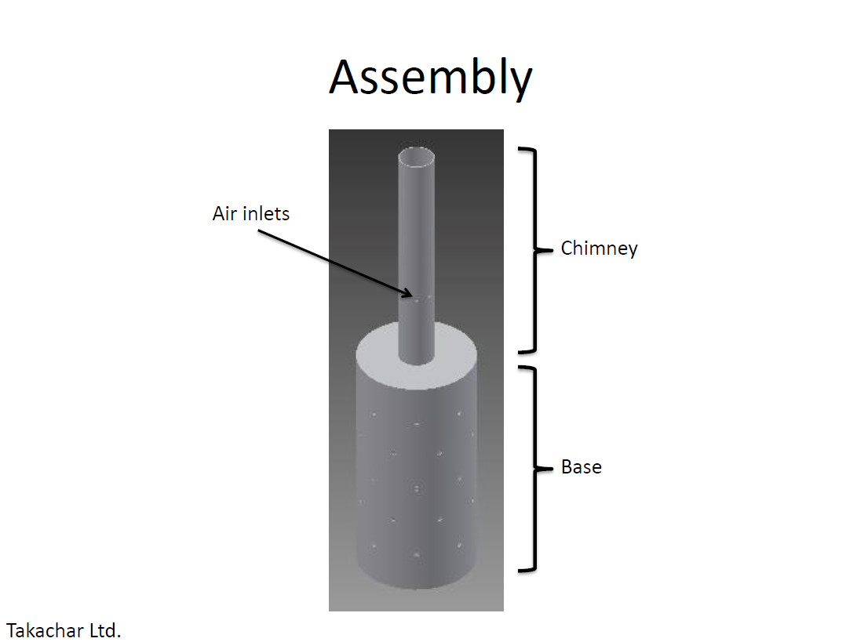

2.1.1 Specifications of Materials

The following is the list of materials needed for making one unit of the converter:
- One (1) metal sheet
Preferably stainless steel, gauge 16 or thicker, 1 m(100cm) by 0.60 m(60cm)
- One (1) metal disc
Preferably stainless steel, gauge 16 or thicker, OD 0.3 m(30cm) x ID² 0.1 m(10cm)
- One (1) metal pipe
Preferably stainless steel, gauge 16or thicker, about OD 0.1 m(10cm) x 0.6 m long(60cm)

A video link has been attached to the annexure for the step by Step process on making the converter.

Step 1: Purchase 16-gauge sheet metal
- Mild steel sheet which have 16 Gauge (thickness = 0.0016 m(0.16cm)

Justification for using 16 - gauge sheet metal
- This gauge sheet are easily to roll using manual rollers those small diameter, simplicity on holes drilling and less costfull

Step 2: Measure sheet metal to respective dimensions by using tape measure
- Chimney: measure 0.6 m (60cm) length and 0.32m (32cm) width (circumference of circle) for chimney
- Base: measure 0.6m (60cm) length and 0.95m(95cm) width (circumference of circle) for base
Step 3: Cut sheet metal to respective dimensions using grinder

Step 4: Drill three holes with the diameter of 0.0127 m (1.27cm) on the chimney sheet with a distance of 0.1m(10 cm) from one end of the metal sheet and on the base drill holes after every 0.1m( 10 cm)
- Measure and place a mark on the metal sheet of chimney where three holes will be drilled at a distance of 0.1m(10cm) from one end of chimney metal sheet which will be welded on the top lid
- Measure and draw vertical and horizontal lines after every 0.1m(10cm) on the metal sheet of base then place marks on all points of line intersections
- Drill holes on marks placed on the base and chimney
- Punch machine used to drill holes on those metal sheets

Justification for having holes
- We drill three holes on the chimney sheet to allow air entrance to support combustion of firewood
- On the base we drill holes to escalate hot air flow for carbonization of the agriculture residues

Step 5: Rolling
- Roll the base and chimney sheet to obtain 0.3m(30cm) and 0.1m(10cm) diameter respectively
  - Roller tool is used
  - During rolling, allow for some overlap between the joining ends of sheet for welding purposes

Step 6: Welding Preparation
- Cut a circular disc as a top lid of base with a diameter of 0.3 meter(30cm) and at the centre of lid drill holes of the same as chimney diameter (0.1 meter)
  - Circular shear machine used

Step 7: Welding
- Weld top lid on the base
- Weld chimney to the top lid

2.2 Conversion of rice husks to biochar and Bio-fuel briquettes

2.2.1 Feedstock selection
First, it is important to make a list of locally available input feedstocks that can be used for the conversion. Not all input feedstocks are created equal. Different types of feedstocks have different local availability, characteristics, moisture contents, and chemistries. Therefore, not all feedstocks are equally suitable for biofuel or biofertilizer production. In this project, we did not thoroughly map out all types of feedstocks, but rather focus on two locally available types: coconut shells and rice husks. Based on laboratory analysis and existing literature, coconut shells are considered a premium feedstock for fuel briquette production, which is why Agricycle currently uses it for its Tropicoal Ignition process. On the other hand, while we attempted to make fuel briquettes from rice husks, we found that, owing to the high ash content (as high as 17% in raw biomass from laboratory analyses), when we attempted to combust the rice husk fuel briquettes, the briquettes sometimes quickly get covered in ash, resulting in suboptimal cooking results. Incidentally, the same ash in rice husks that poses a barrier for fuel combustion is also valuable for fertilizer, for it contains minerals. Therefore, for biofertilizer production, we have specifically focused on rice husks. However, other types of locally available biomass such as palm kernel shells, sugarcane bagasse, and coconut shells may be more amenable for biofuel briquette production.

2.2.2 Biochar Attributes
Biochar is a relatively new term, yet it is not a new substance. Soils throughout the world contain biochar deposited through natural events, such as forest and grassland fires. Biochar is the carbon-rich product obtained when Agriculture residues, such as rice husks,coconut shells, manure or leaves, are heated in a closed container or surrounding a converter with little or no available air. In more technical terms, biochar is produced by so-called thermal decomposition of organic material under limited supply of oxygen (O2), and at relatively low temperatures (<700°C). Biochar application to soils is presently attaining universal attention due to its potential to improve water holding capacity, soil nutrient retention capacity, and sustainable carbon storage, thus reducing greenhouse gas emissions.

2.2.3 Carbonization process
Step 1
Fill the converter base with flammable material then start up the fire and wait for 5 to 7 minutes for the fire to be well distributed. Then mount-up the converter to stand vertically. Flammable material could include rice straws or even newspaper. | 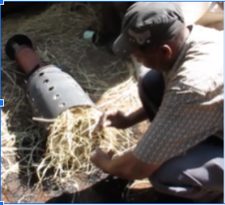
Step 2
Apply rice husks around the converter base until it covers the whole base which has a height of (0.6 meter(60cm)) | 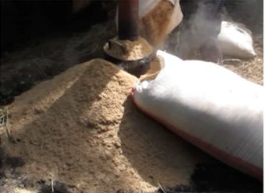
Step 3
Keep the converter base covered with biomass waste. The maximum rise husks that you can apply around the converter is 200kg of rice husks per batch for efficient carbonization. | 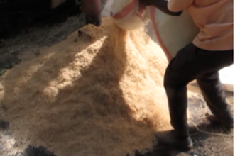
Step 4
Rice husks will change color (to black) and this color change process starts after 30 minutes. Make sure you are around for monitoring and turning up and down those husks for efficient carbonization. A spade may be used | 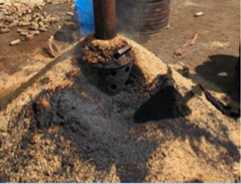
Step 5
Finished product allowed to cool and dry  This is a cooling process; water can be used to speed up the cooling process (30 litres per batch) so as to avoid the possibility of biochar turning into ash (the complete loss of carbon from biochar). The char will take about 2 to 6 hours to be completed and this time varies according to moisture content in raw materials. Lesser the moisture content, the less time it takes.  The capacity of this converter is 200kg of rice husks to produce 70kg of biochar per batch. This means it has a conversion rate of approximately 35% from biomass to biochar. | 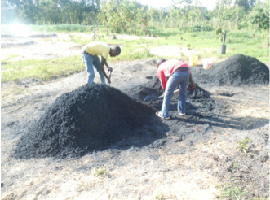

3.0 Biofuel Production

3.1 Milling
After the Rice husk carbonization is complete, the resultant biochar is often milled to sub-1 mm powder (optional with rice husk biochar). This can be done using a standard hammer mill by selecting a sieve of the appropriate size (holes size 1 mm) and passing the feedstock through at least once. Biochar from rice husks do not require size reduction and can be mixed with binder (starch, which can be extracted from cassava) without compromising the quality of biofuel production.

3.2 Biofuel briquette
A fuel is any material that can be made to react with other substances so that it releases chemical or nuclear energy as heat or to be used for work. Fuel briquette is then defined as a compressed block of biochar or other combustible biomass material such as charcoal, sawdust, peat or paper used for fuel. Briquetting can be done with or without a binder. Doing without the binder is more convenient but it requires sophisticated and costly presses and drying equipment which makes such processes non attractive to low and middle income countries( LMIC). Briquettes are frequently classified into various categories based on their constituent fuel type and occasionally, the shape of the briquette itself (i.e. rectangular and cylindrical shape). Common types of briquettes as per constituent fuel include among others; - biomass briquettes, residential and / or municipal waste briquettes, agro-waste briquettes, coal briquettes.

Briquette is produced from prepared biochar which is mixed with warm starch porridge that acts as a binder. This starch which is extracted from cassava, is boiled in water to achieve a sticky binding consistency. Then sufficient binder (binder required is 15% of total weight intended mixture) is added to the charred powder which is 85% of total intended mixture and mixed together for 10 minutes on the mixer such that one can form a clumpy ball with one’s hand. Paddle mixer is more preferred due to efficiency on this type of materials and has the capability to mix 50kg per batch or more. The required ratio for Rice husk char and binder is 85:15 where 85% is for rice husk char and 15% for binder(starch). Then the mixture is passed through a standard briquette press. The photo below shows an example of such an extrusion-based press.

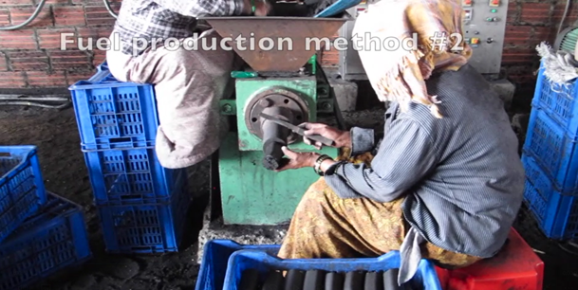

The briquettes are left to dry. This can be done in the sun on drying racks, or in an alternative drier which has a source of heat from electricity, gas and firewood. It takes two days to dry in the sun and 3 to 5 hours in the alternative drier at a temperature range of 110C to 160C. The briquettes are then packaged and branded for consumption.

Key Points to note during Biofuel production
- Recommended ratio of binder and biochar is 15% binder and 85% biochar. Avoid large binder ratios as this will reduce calorific value of briquettes and increase ash content.

4.0 Biofertilizer Production
After carbonization, in the wet-process biochar is mixed with DAP (Diammonium Phosphate) during planting and NPK (Nitrogen, Phosphorus, and Potassium) 23:23 during top-dressing in one of the four plots at the ratio of 10gm:10gm per each stem. DAP:biochar (1:1) is applied during the nursery stage. Then NPT:biochar (1:1) is applied during the top dressing stage, 3 and 7 weeks after planting. Biochar retains moisture and nutrients for a timed release. During mixing, residual moisture from the cooling process will be retained. Fertilizers are normally in granular and powder form; on selection it depends on the farmers and the types of crops. Some farmers prefer granulated form for certain crops. But as top dressing for tomatoes, powdered form is sufficient and in many cases preferable to granulated form.

This can be customized to the local contexts whereby the following mixtures have been experimented:

- Basal fertilizer: DAP(Di Ammonium Phosphate), at standard recommended application rate per hectare (Rate per hectares ranges from 50 - 100 grams)
- Top dressing: NPK (Nitrogen,Phosphorus and Potassium) 23:23, at standard recommended application rate per hectare (10 gram per stem)
- Application of 150-300 kg of biochar/hectare
- Standard application rate is 10gram per stem for both NPK and DAP fertilizers

The produced bio fertilizer is then packaged and branded for field application.

5.0 Conclusion

5.1 Strengths
- Local government authorities have been supportive to get the project smoothly implemented in the region.
- Some farmers have taken ownership of the project by offering their own land for the project implementation.

5.2 Challenges
- Limited buy-in to the project by some of the enrolled farmers. This has projected less ownership of the project and uncertain sustainability from farmers, especially with the converter being a new technology that may take some time for them to adopt.
- Prolonged authorizations and approval processes from the government, for instance acquiring a phytosanitary certificate to export soil samples proved to be a month-long process.
- Limited availability of converter fabrication materials in morogoro hence being fabricated in Dar es Salaam and transported to Morogoro. (transport costs increased the general converter budget)

6.0 Recommendations of technical fabrication
- Do not use thin sheet metal because it is difficult to Metal Inert Gas (MIG) weld (easily burn through). While using thicker sheet metal would make welding easier, the “rolling” step of the base and chimney would be difficult. That 16 gauge sheet metal which is preferred.
- It is essential to place aluminum “sink” behind the section of metal being welded in order to prevent burn-through
- Avoid using galvanized steel as it releases harmful fumes when welding (and possibly during the carbonization step, too)
- Rolling the chimney sheet metal to obtain a diameter of 0.09 m is challenging when manually using a roller. This led us to adjust to 0.1 m

7.0 Annexes
- Technical Drawing
- Video explaining the Converter fabrication
- Carbonization Process Video
- Glossary of terms used in this document
- Flowchart for Production of fertilizer and briquettes
- Bill of Materials for converter fabrication

OD: Outer Diameter ² OD: Inner Diameter

